Inheritance

1. What is the Single- responsibility principle? Principle (SRP)?
   1. Many specific interfaces are better than general purpose interfaces.
   2. There is no need for modules to depend on each other
   3. Software entities should be open for extension, but closed for modification
   4. An object in a program could be replaced with instances of its subtypes without altering the normal behavior of the program.
   5. An object should have only one responsibility
   6. We should depend on abstractions and not on concretizations.
2. What is the Open/ Closed principle? Principle (OCP)?
   1. An object should have only one responsibility
   2. Software entities should be open for extension, but closed for modification
   3. An object in a program could be replaced with instances of its subtypes without altering the normal behavior of the program.
   4. Many specific interfaces are better than general purpose interfaces.
   5. There is no need for modules to depend on each other
3. What is the Liskov principle? Substitution Principle (LSP)?
   1. An object should have only one responsibility
   2. Software entities should be open for extension, but closed for modification
   3. An object in a program could be replaced with instances of its subtypes without altering the normal behavior of the program.
   4. Many specific interfaces are better than general purpose interfaces.
   5. There is no need for modules to depend on each other
4. The following statement. What is the SOLID principle that it refers to?

**"A class must have a unique reason to change"**

* 1. Single Responsibility Principle
  2. Open-Closed Principle
  3. Liskov Substitution Principle
  4. Interface Segregation Principle
  5. Dependency Investment Principle

1. The following statement. What is the SOLID principle that it refers to?

**"Inheritance must guarantee that any property tested for any object in the superclass must be valid for any object in the subclass"**

* 1. Single Responsibility Principle
  2. Open-Closed Principle
  3. Liskov Substitution Principle
  4. Interface Segregation Principle
  5. Dependency Investment Principle

1. next statement. What is the SOLID principle that it refers to?

**"Software entities should be open for extensions, but closed for modifications"**

* 1. Single Responsibility Principle
  2. Open-Closed Principle
  3. Liskov Substitution Principle
  4. Interface Segregation Principle
  5. Dependency Investment Principle

1. The following image explains one of the SOLID principles. What is the principle you refer to?



* 1. Single Responsibility Principle
  2. Open-Closed Principle
  3. Liskov Substitution Principle
  4. Interface Segregation Principle
  5. Dependency Investment Principle

1. In the following example the principle of Single Responsibility was applied principle .

Is the proposed solution correct?

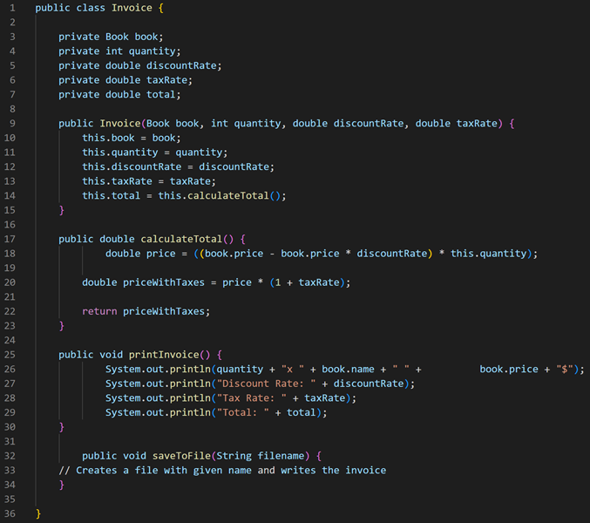

* 1. TRUE
  2. False

1. The following diagram represents the Liskov principle. substitution principle

Is there a breach of the LSP principle?

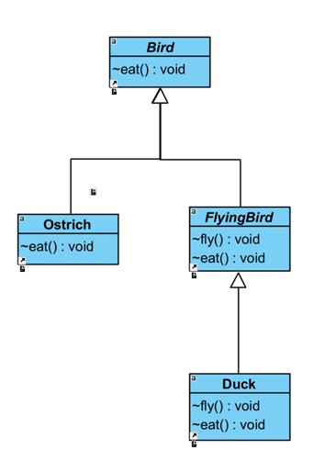

* 1. TRUE
  2. False

1. What are the advantages of the Single Responsibility principle ?
   1. Each responsibility should reside in a separate class, since each responsibility is a "source" of change.
   2. A class must have only one change reason
   3. Classes and methods that follow the SRP principle are smaller and easier to understand and maintain.
   4. The methods are easier to test.
   5. Objects in a program must be replaceable with instances of their subtypes without altering the behavior of the program.